34 38

Name: __________________
Date: __________________

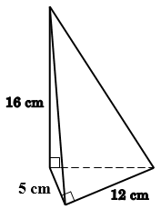
1. What is the volume of pyramid in the figure?
A. $320 {cm}^{3}$
B. $230 {cm}^{3}$
C. $160 {cm}^{3}$
D. $80 {cm}^{3}$

C

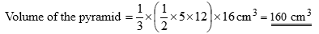

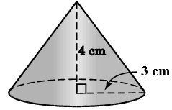
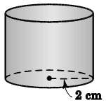
2. In the figure, the height of the right circular cone is $4 cm$ and its base radius is $3 cm$. The base radius of the cylinder is $2 cm$. If they have the same volume, find the height of the cylinder.
A. $2 cm$
B. $3 cm$
C. $4 cm$
D. $6 cm$

B

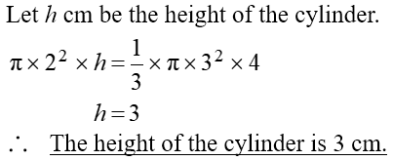

3. $27$ small solid metal spheres each of radius $3 cm$ are melted and recast into a larger solid metal sphere.
Find the surface area of the large sphere in terms of $π$.
A. $36π {cm}^{2}$
B. $162π {cm}^{2}$
C. $324π {cm}^{2}$
D. $972π {cm}^{2}$
C

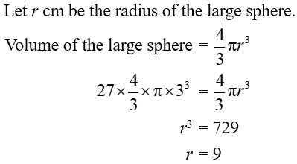
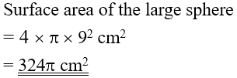

4. The surface area of a sphere is $64π cm^{2}$. Find the volume of the sphere.
A. $\frac{64}{3}π cm^{3}$
B. $\frac{128}{3}π cm^{3}$
C. $64π cm^{3}$
D. $\frac{256}{3}π cm^{3}$
D
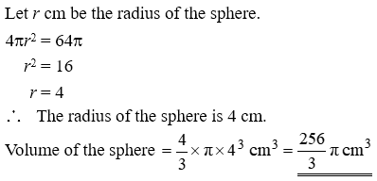

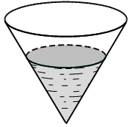
5. A vessel in the shape of an inverted right circular cone containing $324 {cm}^{3}$ of water is placed vertically. If the depth of water in the vessel is $\frac{3}{5}$ of the height of the vessel, find the capacity of the vessel.
A. $540 {cm}^{3}$
B. $750 {cm}^{3}$
C. $1250 {cm}^{3}$
D. $1500 {cm}^{3}$

D

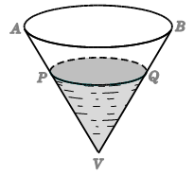
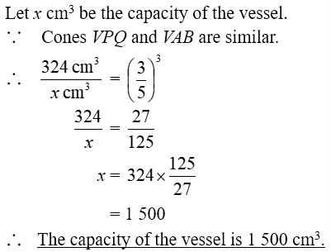

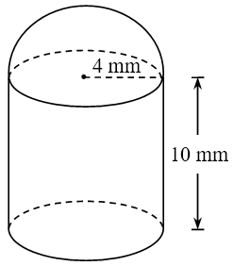
6. The figure shows a small component of a plastic model. The shapes of its upper part and lower part are a hemisphere and a cylinder respectively. Their base radii are $4 mm$ and the height of the cylinder is
$10 mm$. Find the volume of the component.
(Give the answer correct to $3$ significant figures.) (3 marks)

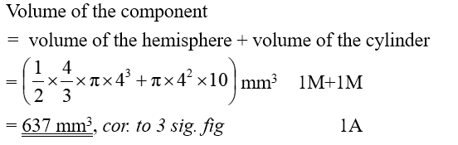

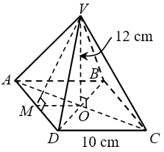
7. The height of a solid right pyramid with a square base of side $10 cm$ is $12 cm$. Find the total surface area of the pyramid. (4 marks)

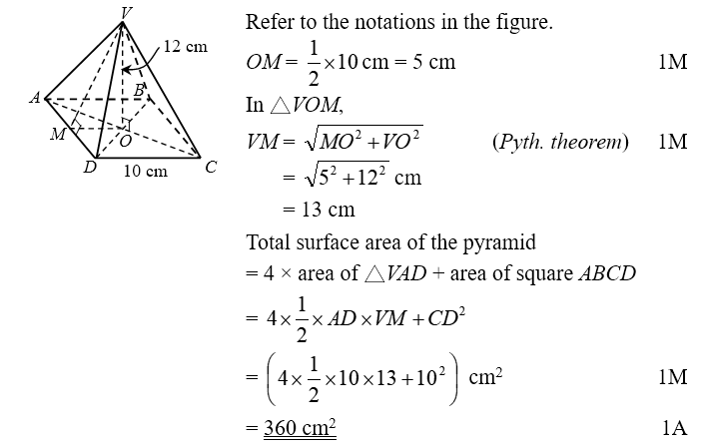

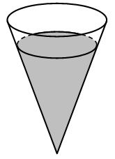
8. The figure shows a vertical right conical vessel containing some water. The ratio of the curved surface area of the vessel to area of the surface of the vessel in contact with water is $36 :25$.
(a) Find the ratio of the base radius of the vessel to the radius of the water surface. (2 marks)
(b) It is given that the vessel contains $600 {cm}^{3}$ of water. Alex claims that if $300 {cm}^{3}$ of water is
added into the vessel, the water will overflow. Do you agree? Explain your answer. (5 marks)

